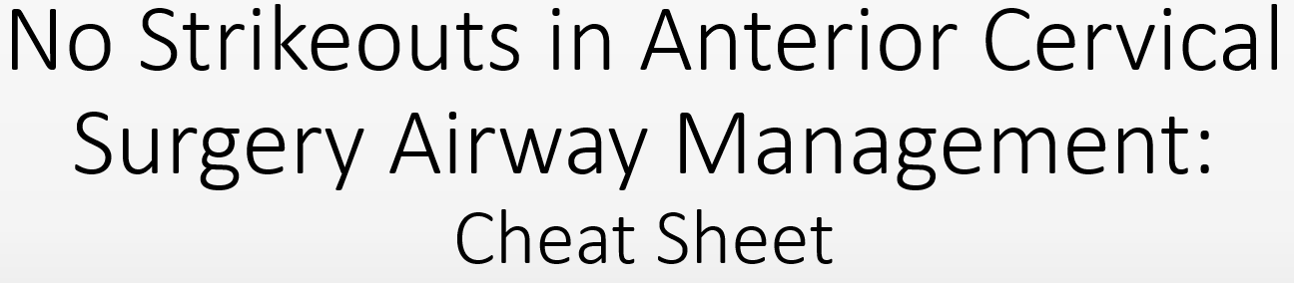
Routine Outpatient Post-Operative Anterior Cervical Surgery Care
- Mandatory 4-hour post-operative observation
- Neurologic exam prior to discharge
- Discharged only if the patient has the support of a competent adult overnight
- Surgery center adherence to “No Strikeouts in Anterior Cervical Airway Management Protocol”
If concern for airway issues or post-operative hematoma the evaluating staff (Surgeon, Anesthesia, Nurse, PA) initiates “Initial Airway Assessment”
Components of “Initial Airway Assessment”
- Staff notifies other staff members in proximity that airway assessment has been initiated
- Onsite anesthesia team is contacted and must evaluate the patient at bedside
- Surgeon is contacted and notified that airway assessment has been initiated
- Staff members in proximity bring the crash cart to the patient’s bedside

Anesthesia team then decides based off evaluation if No Strikeouts in Anterior Cervical Surgery Airway Management is initiated
If triggered the following must occur:
- The “No Strikeouts” protocol is taken to completion
- The patient must return to the OR for wound exploration & hemostasis

No Strikeouts in Anterior Cervical Surgery Airway Management
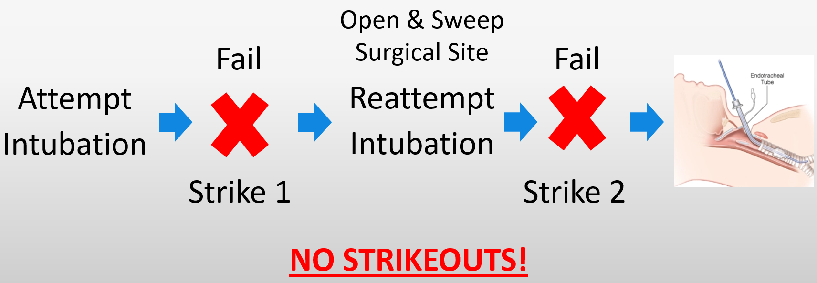
Crash Cart Cricothyroidotomy Kit Anesthesia OR Cricothyroidotomy Supplies
